Collection Interface:
Operation | Description
add(E e) | Adds an element to the collection.
addAll(Collection c) | Adds all elements from another collection.
remove(Object o) | Removes the specified element.
removeAll(Collection c) | Removes all elements that are also present in another collection.
retainAll(Collection c) | Keeps only the elements that are present in another collection.
clear() | Removes all elements from the collection.
contains(Object o) | Checks whether the collection contains a particular element.
containsAll(Collection c) | Checks whether all elements of another collection are present.
isEmpty() | Checks whether the collection has no elements.
size() | Returns the number of elements in the collection.
iterator() | Returns an iterator used to traverse the collection.
toArray() | Converts the collection into an array.
equals(Object o) | Compares the collection with another object for equality.
hashCode() | Returns the hash code of the collection.

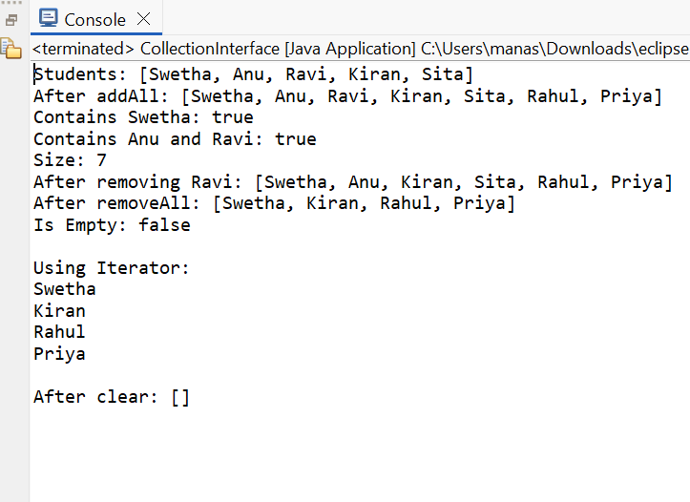
Deque Interface:
Operation | Description
addFirst(E e) | Adds an element at the beginning.
addLast(E e) | Adds an element at the end.
offerFirst(E e) | Adds an element at the beginning; returns false if it cannot be added.
offerLast(E e) | Adds an element at the end; returns false if it cannot be added.
removeFirst() | Removes and returns the first element.
removeLast() | Removes and returns the last element.
pollFirst() | Removes and returns the first element; returns null if empty.
pollLast() | Removes and returns the last element; returns null if empty.
getFirst() | Returns the first element without removing it.
getLast() | Returns the last element without removing it.
peekFirst() | Returns the first element; returns null if empty.
peekLast() | Returns the last element; returns null if empty.
push(E e) | Adds an element to the beginning of the deque.
pop() | Removes and returns the first element.

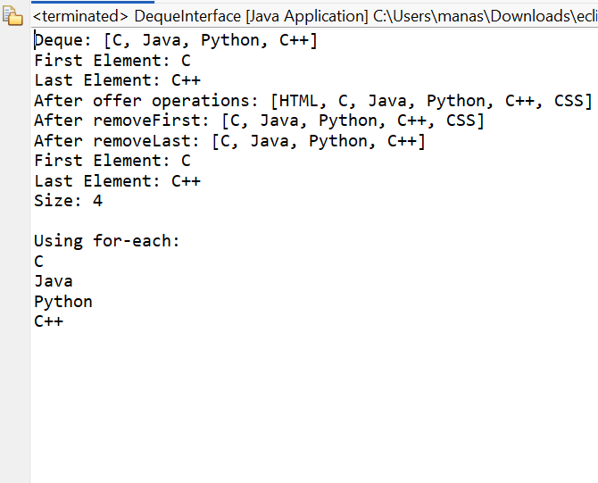
Iterator Interface:
Operation | Description
hasNext() | Checks whether another element is available.
next() | Returns the next element.
remove() | Removes the last element returned by the iterator.
forEachRemaining() | Performs an action on each remaining element.

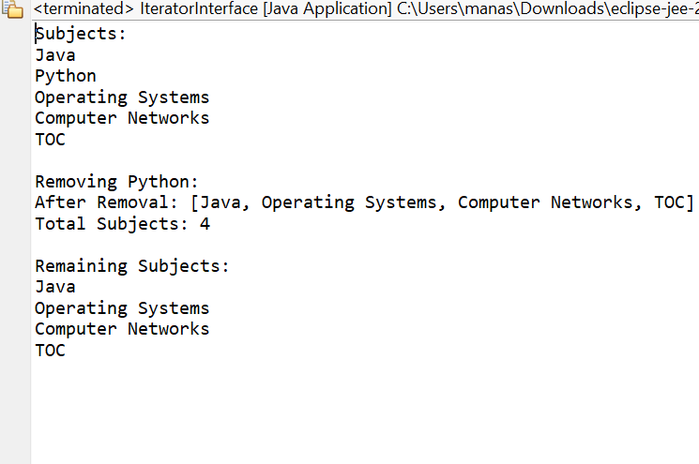
List Interface:
Operation | Description
add(E e) | Adds an element to the list.
add(int index, E e) | Adds an element at the specified index.
addAll(Collection c) | Adds all elements of another collection.
addAll(int index, Collection c) | Adds another collection starting at the specified index.
get(int index) | Returns the element at the specified index.
set(int index, E e) | Replaces an element at the specified index.
remove(int index) | Removes the element at the specified index.
remove(Object o) | Removes the specified element.
indexOf(Object o) | Returns the first occurrence index.
lastIndexOf(Object o) | Returns the last occurrence index.
contains(Object o) | Checks whether the element exists.
subList(int from, int to) | Returns a portion of the list.
size() | Returns the number of elements.
isEmpty() | Checks whether the list is empty.
clear() | Removes all elements.
iterator() | Returns an iterator for traversal.
listIterator() | Returns a list iterator.

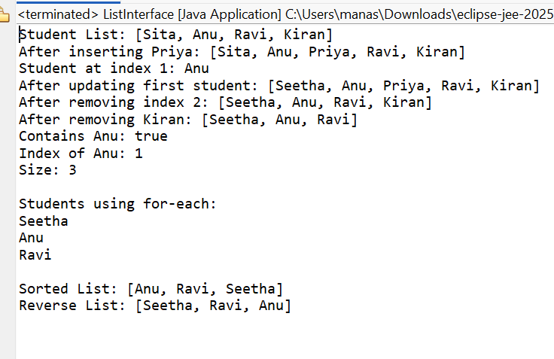
ListIteratorInterface:
Operation | Description
hasNext() | Checks whether a next element exists.
next() | Returns the next element.
hasPrevious() | Checks whether a previous element exists.
previous() | Returns the previous element.
nextIndex() | Returns the index of the next element.
previousIndex() | Returns the index of the previous element.
add(E e) | Adds an element to the list.
set(E e) | Replaces the last element returned.
remove() | Removes the last element returned.

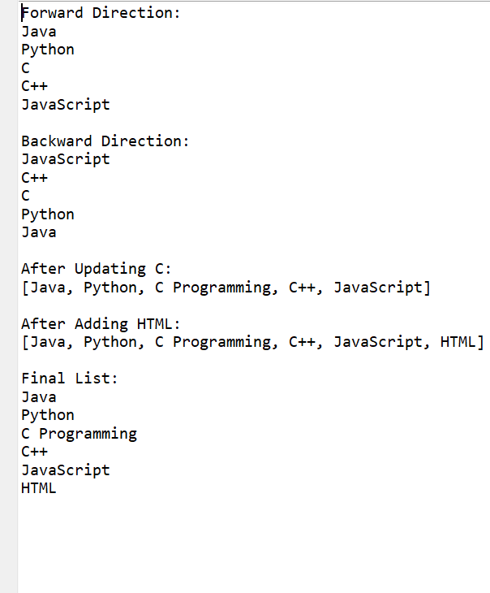
MapInterface:
Operation | Description
put(K key, V value) | Adds or updates a key-value pair.
putAll(Map m) | Adds all mappings from another map.
get(Object key) | Returns the value associated with a key.
getOrDefault(K key, V defaultValue) | Returns the value or a default value if key is absent.
remove(Object key) | Removes the mapping for the specified key.
containsKey(Object key) | Checks whether a key exists.
containsValue(Object value) | Checks whether a value exists.
keySet() | Returns all keys as a Set.
values() | Returns all values.
entrySet() | Returns all key-value pairs.
size() | Returns the number of mappings.
isEmpty() | Checks whether the map is empty.
clear() | Removes all mappings.
replace(K key, V value) | Replaces the value of an existing key.
replaceAll() | Replaces values using a specified function.
putIfAbsent() | Adds a mapping only if the key is absent.

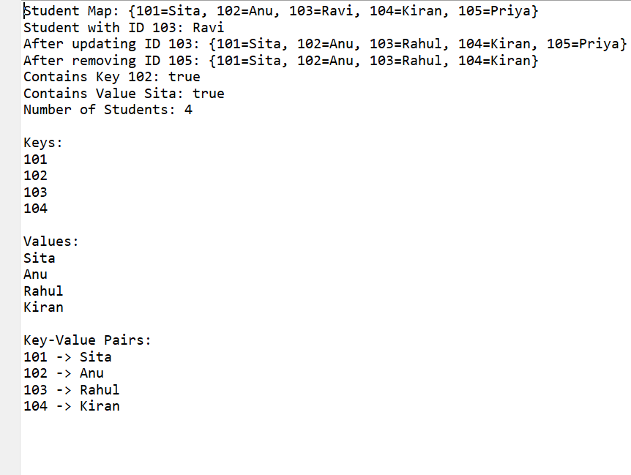
NavigableMapInterface:
Operation | Description
lowerKey(K key) | Returns the greatest key strictly less than the given key.
floorKey(K key) | Returns the greatest key less than or equal to the given key.
ceilingKey(K key) | Returns the smallest key greater than or equal to the given key.
higherKey(K key) | Returns the smallest key strictly greater than the given key.
lowerEntry(K key) | Returns the entry with the greatest key less than the given key.
floorEntry(K key) | Returns the entry with the greatest key ≤ given key.
ceilingEntry(K key) | Returns the entry with the smallest key ≥ given key.
higherEntry(K key) | Returns the entry with the smallest key greater than the given key.
firstEntry() | Returns the entry with the smallest key.
lastEntry() | Returns the entry with the largest key.
pollFirstEntry() | Removes and returns the first entry.
pollLastEntry() | Removes and returns the last entry.
descendingMap() | Returns the map in reverse order.
descendingKeySet() | Returns keys in descending order.

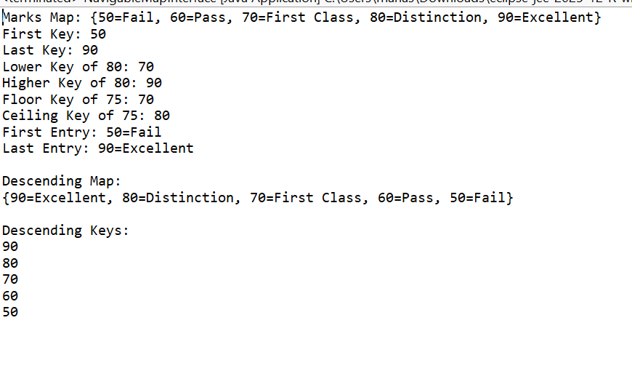
QueueInterface:
Operation | Description
add(E e) | Adds an element to the queue.
offer(E e) | Adds an element; returns false if it cannot be added.
remove() | Removes and returns the head element.
poll() | Removes and returns the head; returns null if empty.
element() | Returns the head without removing it.
peek() | Returns the head; returns null if empty.

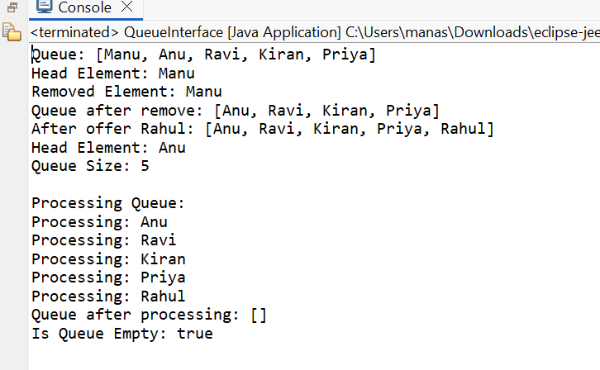
SetInterface:
Operation | Description
add(E e) | Adds an element if it is not already present.
addAll(Collection c) | Adds all unique elements from another collection.
remove(Object o) | Removes the specified element.
removeAll(Collection c) | Removes elements that are present in another collection.
retainAll(Collection c) | Keeps only common elements.
contains(Object o) | Checks whether an element exists.
containsAll(Collection c) | Checks whether all elements exist.
size() | Returns the number of elements.
isEmpty() | Checks whether the set is empty.
clear() | Removes all elements.
iterator() | Returns an iterator for traversal.

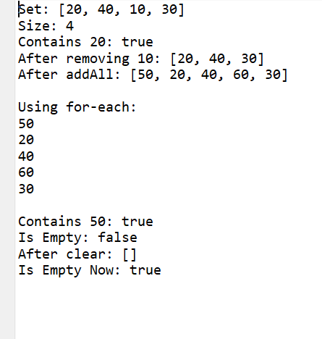
SortedMapInterface:
Operation | Description
firstKey() | Returns the smallest key.
lastKey() | Returns the largest key.
headMap(K key) | Returns mappings whose keys are less than the given key.
tailMap(K key) | Returns mappings whose keys are greater than or equal to the given key.
subMap(K fromKey, K toKey) | Returns mappings between two keys.
comparator() | Returns the comparator used for ordering, or null for natural ordering.
keySet() | Returns all keys as a sorted set.
values() | Returns all values.
entrySet() | Returns all key-value pairs.

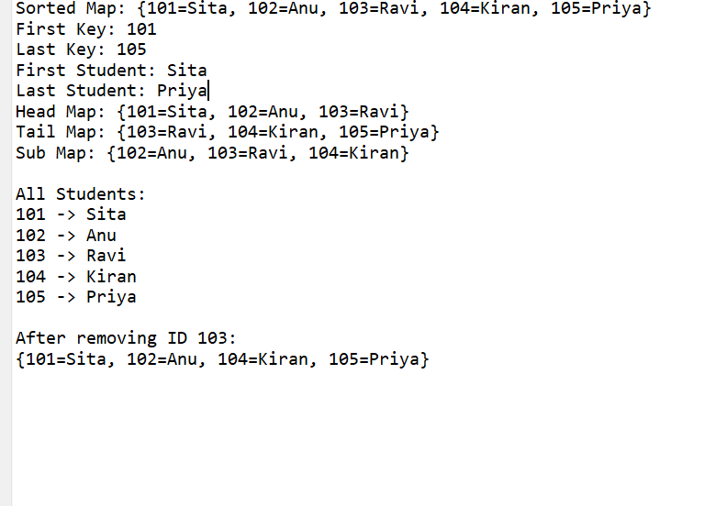
SortedSetInterface:
Operation | Description
first() | Returns the smallest element.
last() | Returns the largest element.
headSet(E e) | Returns elements smaller than the specified element.
tailSet(E e) | Returns elements greater than or equal to the specified element.
subSet(E from, E to) | Returns elements between two specified elements.
comparator() | Returns the comparator used for sorting.
add(E e) | Adds an element if it is not already present.
remove(Object o) | Removes the specified element.
contains(Object o) | Checks whether an element exists.
size() | Returns the number of elements.
isEmpty() | Checks whether the set is empty.
clear() | Removes all elements.
iterator() | Returns an iterator for traversal.

